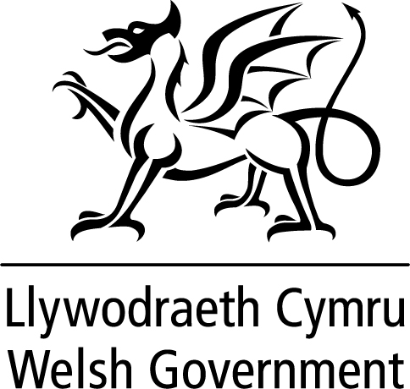
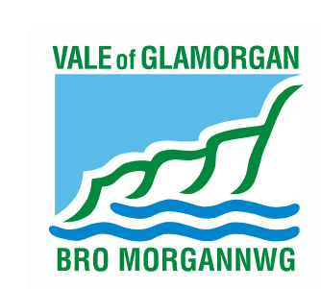
Empty Property
Landlord Loan
Frequently Asked Questions

This document is available in Welsh / Mae’r ddogfen hon ar gael yn Gymraeg

Q. What are Empty Property Landlord Loans?
Empty Property Landlord Loans (previously referred to Houses Into Homes Loans) are made available through the Houses Into Homes Scheme to enable the renovation and improvement of single properties or the conversion of empty properties into a number of units, so that they are suitable for use as residential accommodation.

Q. Who can apply for a loan?
Individuals and companies can apply for a loan, if they already own an empty property or are considering buying an empty property in Wales.

Q. For how long must a property have been empty before I can apply for a loan?
Loans can only be made available for properties that have been empty for at least six months or more.

Q. Does the property have to be an existing dwelling to be eligible for a loan?
No. We will consider applications for loans to convert empty commercial properties into residential accommodation. However, it is very likely that you will need planning permission for the conversion and so you are strongly urged to contact the local planning department to discuss your proposals. We will only consider a loan application if the relevant planning permission has been granted.

Q. What is the maximum amount of loan I can apply for?
The maximum loan amount you can apply for is £35,000 per property or unit, up to a total maximum of £250,000 per applicant. If you are applying for a loan to convert one building into four units, the maximum loan you can apply for is £140,000. The maximum amount of loan per application is £250,000. The actual amount of loan that will be approved will be dependent on the actual cost of the works, e.g. if the works are calculated to cost £10,000 this is the most the loan will be approved for.

Please note that any loan offered, taking into account any existing mortgage cannot exceed 80% of the current property value. Therefore, if you have an existing mortgage of £65,000 on a property with a current market value of £100,000, then the maximum loan that can be approved is £15,000,

Current Value £100,000
Mortgage & Loan £65,000 & £15,000 = £80,000 (Maximum 80% Loan to value)

It is possible in certain cases for another property to be used as security for the loan.

Where the cost of the works exceeds the value of the loan, then the applicant must be able to show that they have adequate funds to completed the development

Q. What do I have to do with the property or units after completion of the works?
You can either let the property/units or you can sell the property/units to a new owner. Loans are not available for people wanting to renovate the property and live in it as their own principal home.

Q. Does the work/conversion have to be carried out to any sort of standards?
Yes. All work must be carried out in accordance with any planning permissions or building regulation approvals made in respect of the property. Additionally, the work must comply with the agreed Schedule of Works. The property must be renovated/converted to a reasonable standard, free from any serious hazards (as a minimum), so that it is suitable for immediate occupation.

Q. Are there any conditions attached to approving the loan?
Yes: -
- You must carry out the conversion/repair works within an agreed time period.
- The property/units must be marketed for sale or for let within a reasonable period of time after completing the works (12 weeks). If the property/units are available for rent and are not occupied within this time period, then the loan may become repayable.
- The loan must be repaid either on or before the date as specified in your Loan Facility Agreement.
- A financial charge will be made on the property for the lifetime of the loan.
- More information about the conditions can be found in the loan information booklet or contact the Empty Property Officer for further clarification.

Q. Are the loans secured loans?
Yes. All loans approved must be secured by a first or second financial charge being secured against the property. If there is an existing mortgage on the property, we will need the lenders consent to secure our charge.

Q. I am interested in applying for a loan, what do I do next?
You will need to contact the Empty Homes and Housing Loans Officer (contact details below) by email, phone or by using the Online Form on the website and provide the following information in order to establish if we can be of assistance:

- Your name, address and contact details
- The address of the property for which you would like to apply for a loan
- A brief summary of the works to be undertaken
- The anticipated cost of the works
- How many units of accommodation the conversion/renovation works will
provide on completion.
- If the property/units will be sold or made available for letting on completion
of the works.
- How the loan will be repaid.

Q. What is the interest rate for the loan?
The loans are interest free, providing there is no default on the loan.

Where the loan is not repaid in accordance with the loan conditions, a breach of conditions will have occurred. In such instances, The Vale of Glamorgan Council may demand immediate repayment of the loan and interest at 6%.

Q. Are there any fees attached to the loan?
Yes. An administration fee will be required as a contribution towards the costs of processing your application.

£590 is payable for a loan application for single property. An additional £50 will be payable for each additional property included in the loan application (to be refurbished or created).

For example, if you are converting an existing property into 6 flats, the administration fee will be £590 + (5 X £50) = £840

Q. When will I have to repay the loan?
This will depend on what you intend to do with the property on completion of the works.

- If you are renovating a single property, which is to be sold, the loan must be repaid when the property is sold or up to 2 years from the date of the loan approval, whichever is the sooner.

- If you are converting a property into a number of units, which are to be sold on completion of the works, it is expected that the loan must be repaid on sale of the first unit, or two years, whichever is the sooner. However, we will endeavour to arrange a mutually agreeable repayment schedule.

- If the property/units are to be made available for letting the loan must be repaid within 5 years from the date of the loan approval. However, if the property is let via the Council’s Vale Assisted Tenancy Scheme or equivalent, the loan period can be set to 10 years.

- All loans can be repaid earlier if the applicant wishes to do so.

Q. How do I get more information about the loan scheme?
All persons making an enquiry and deemed to be eligible will receive an Empty Property Landlord Loan pack which will include:-
- Information booklet
- Application form
- A Template Loan Facility Agreement
- A Template Legal Charge Agreement

If you would like to discuss your property or require further clarification, then please do not hesitate to contact:

Eleri Nicholas,
Empty Homes and Loans Officer,
Regeneration and Planning,
Vale of Glamorgan Council,
Dock Offices,
Subway Road,
Barry,
CF63 4RT

Tel: 01446 704721
Email: housingloans@valeofglamorgan.gov.uk

Correspondence is welcomed in Welsh or English/Croesawir Gohebiaeth yn y Gymraeg neu yn Saesneg

