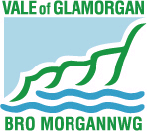
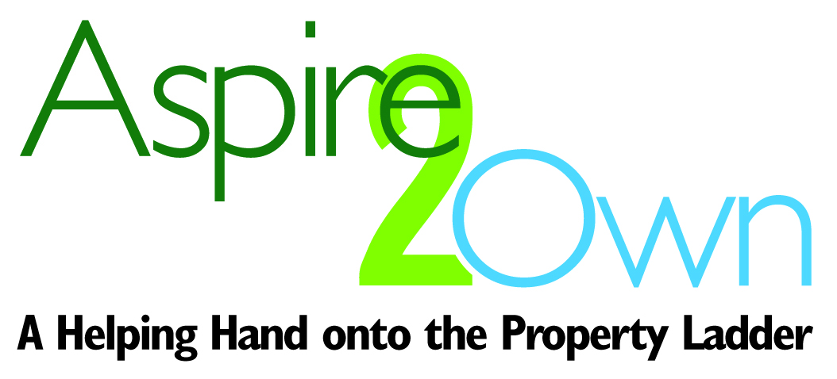

Low Cost Home Ownership
APPLICATION FORM

Please let us know if you need help completing this form or if you would like a copy of the form in an alternative format or language:

01446 709476 / 01446 709433

housingstrategy@valeofglamorgan.gov.uk www.valeofglamorgan.gov.uk/Aspire2Own

Cewch y ffurflen hon mewn gwahanol fformatiau ac ieithoedd drwy holi. Gallwn hefyd eich helpu i lenwi’r ffurflen. Mae croeso i chi ddefnyddio’r manylion uchod i gysylltu â Strategaeth Tai

Please note the information that you provide on this form is confidential.

FOR OFFICE USE ONLY
DATE RECEIVED: ___________________________________________________________
APPLICANT NUMBER: _______________________________________________________
STATUS: __________________________________________________________________



PLEASE READ THE FREQUENTLY ASKED QUESTIONS
& ELIGIBILITY CRITERIA FOR THE PROPERTY YOU ARE
APPLYING TO PURCHASE

BEFORE YOU COMPLETE THIS FORM

THE PROPERTY YOU ARE APPLYING TO PURCHASE

- Name of the development:
- Size of property are you applying for / number of bedrooms:

PERSONAL DETAILS

- Applicant(s) details:

 | Applicant 1  (Main Contact) | Applicant 2  (Husband/Wife/Partner
Title
First Name:
Surname:
Address:
Postcode:
Contact number:
Email address:
Date of birth:
Marital status:
Relationship to first person:
- Who else would be living with you (not including yourself or the second person included in the table above)?

Name | Relationship to You | Age | Gender
- Are you or anyone who wishes to be housed with you expecting a baby?
Yes |  | No

If so, who?

HOUSING CIRCUMSTANCES
- What are your current housing circumstances?
Council tenant |  | Private tenant
Housing association tenant |  | Owner occupier
Living with parents / relatives |  | Living with friends
Other, please state:
If you are a Housing Association tenant please tell us who your landlord is:
Are you registered with Aspire2Own?
Yes |  | No
Are you registered with Homes4U?
Yes |  | No

ELIGIBILITY
- Are you a British or EU / EAA Citizen?
Yes |  | No
If ‘No’ is your passport stamped with ‘Indefinite Leave to Remain’?
Yes |  | No
- Please tick all the statements that apply to you:
 | Applicant |  | If  please complete:
 | 1 | 2 | If  please complete:
I am a first time buyer* |  |  | -
I have lived in the Vale of Glamorgan for at least 6 months |  |  | 8a
I have worked in the Vale of Glamorgan for at least 6 months |  |  | 8b
I am due to leave the Armed Forces. Prior to joining the Armed Forces I lived in the Vale of Glamorgan for at least 6 months |  |  | 8c
I have owned a property on my own before |  |  | -
I have owned a property jointly in the past and now consider myself to be a first time buyer* in my own right. |  |  | 8d
8a. Please provide previous addresses covering the last 6 months:
Applicant 1 | Applicant 2
8b. Please provide previous employers, including their addresses, covering the last 6 months:
Applicant 1 | Applicant 2
8c. Please provide previous addresses covering the 6 months prior to joining the armed forces:
Applicant 1 | Applicant 2
Please note you are asked to provide supporting documentation that evidences your residence in the Vale of Glamorgan, e.g. utility bills, bank statements etc
8d. If you have owned a property jointly in the past and now consider yourself to be a first time buyer* ‘in my own right’ please provide details below:

*First Time Buyer - by first time buyer we mean that you have never owned a property with a mortgage in your name only. Consideration will be given to applicants who have jointly owned a property previously, please detail these circumstances above.

FINANCIAL INFORMATION

- Have you received advice about buying a home?
Yes |  | No
- Do you have a mortgage offer?
Yes |  | No
- If you have had a mortgage offer, what amount in principle were you able to obtain?
Amount agreed in principle: | £
- How would you pay the cost involved in buying a home i.e. legal fees etc? Please give details:

- What is your annual gross (before deductions) income (including tax credits and any other benefits you may receive) and occupation?

 | Applicant 1  (Main Contact) | Applicant 2  (Husband/Wife/Partner
Annual income:
Occupation:
Employer’s name and address:
National Insurance No.
- State the amount of savings you hold:
 | Applicant 1 | Applicant 2
Total savings

Total deposit available: | £

- Please provide information about your monthly outgoings / expenditure below:
 | Applicant 1 | Applicant 2 | Or Household
Mortgage/Rent
Council Tax
Electricity & Gas
TV Licence
TV/Internet package
Phone & mobile phone
Water Rates
Insurances (E.g. home/buildings/contents)
Pension contributions
Food/toiletries/clothing/medicines
Entertainment
Child care/child maintenance
Car (E.g. insurance/petrol/maintenance/tax)
Work (E.g. travel/lunches)
Rental – Hire Purchase/catalogues
Loans (E.g. bank/finance/car)
Credit Cards / Store Cards
Court Orders (E.g. CCJ’s)
Other (E.g. gym/activities/holidays/savings)
Total Expenditure
- 11. How did you hear about the scheme?
Council website |  | Other website
Newspaper |  | Leaflet
Poster |  | Email
Word of mouth |  | Housing Association
Facebook |  | Twitter
Other, please state:

SUPPORTING DOCUMENTATION

In order for your application to be progressed you will

need to provide all of the following supporting

documentation for each applicant

Tick if enclosed or mark as not applicable (N/A) | 
Passport or driving licence or birth certificate
Birth certificate or passport for all children on the application
Proof of pregnancy (if applicable)
Last three months’ payslips or a letter from your employer

(The letter should state the applicant’s full salary and any bonus/s or commission earned)
Proof of savings (if applicable)
Proof of benefits received (if applicable)
Letter or certificate from a mortgage lender showing the Mortgage in Principle

(This should confirm that the applicants are able to obtain a mortgage for 70% of purchase price)
Documentation that evidences you have lived in the Vale for six months

(E.g. utility bills or bank statements which include a date and are provided for a period of 6 months)

Scanned images of all of the above documentation are acceptable.
Not including the supporting documentation with your application form will delay your application being processed.

DECLARATION
I / we hereby declare that the information provided in this registration form is correct to the best of my / our knowledge and I / we understand that any false information knowingly given may disqualify me / us from further consideration for the Homebuy scheme.
The information that you provide in completing this form will be treated as confidential, in line with the requirements of the Data Protection Act 1998.
We, the Vale of Glamorgan Council will need to share the information that you provide with the Housing Association partner working on the site you are applying for (Hafod HA, Newydd HA, United Welsh HA or Wales and West HA). We may also need to share the information that you provide with other departments of the Council or relevant outside agencies, in order to process your details. By signing this form you are giving permission for all appropriate work in processing your registration form to be carried out.
Any data supplied by you on this form will be processed in accordance with the requirements of the Data Protection Act 1998. In supplying information on this form to the Vale of Glamorgan Council you are consenting for your data to be processed for the purpose in which it was submitted. All personal information supplied will be treated in the strictest confidence and will only be used by the Council and Housing Association, or disclosed to others for the purpose permitted by law.

PLEASE NOTE: IF THIS IS A JOINT REGISTRATION BOTH
APPLICANTS MUST SIGN THE FORM

 | Applicant 1 | Applicant 2
Signature
Date

PLEASE RETURN COMPLETED FORMS & SUPPORTING DOCUMENTS TO:

housingstrategy@valeofglamorgan.gov.uk

For more information about the Aspire2Own scheme and properties please contact:

01446 709476 / 01446 709433

housingstrategy@valeofglamorgan.gov.uk www.valeofglamorgan.gov.uk/Aspire2Own

Like us on Facebook: https://facebook.com/VOGHousing
Follow us on Twitter @VOGHousing #ValeHousing

