
 MY TURN, YOUR TURN
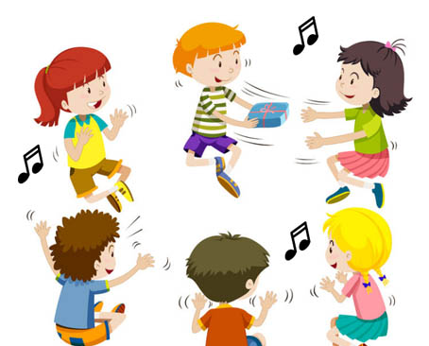
Learning to take turns is crucial for the development of our social skills, friendships, communication and play. Children who get lots of practice taking turns will have an easier time talking and playing with others.

- Model how it’s done
Show them, being a role model for the child provides an opportunity for the child to see the benefit of sharing and taking turns with you and with his friends and peers. Using a puppet or by including another child to act out the ‘proper way’ to take turns in a conversation will show your child what turn taking looks like.
- Use the right language
Use simple key language to help your child understand. Using “My turn”, “your turn” draws attention to one person playing at any one time. Some children may need the verbal reminder to be paired along with a gentle physical reminder such as placing your hand on top of theirs to help them wait or a gentle tap to the shoulder while saying their name to emphasize their turn.
- Practice Waiting
Waiting is often the most difficult part in taking turns for children, especially for little ones. Start with a short periods to wait as they begin to understand you can make the periods longer. A timer or singing a song can help children to predict when their turn ends or begins. Some children may need a toy to hold while they are waiting for their turn which helps to ease some of the tension while waiting.
- Normalise sharing
Find opportunities to ask the child to give out items or something to others in the group. This can normalize sharing for the child and help them understand that sharing is a regular part of life.

Top tips for turn taking –

- Use Social Stories, these can teach the basic concepts of turn taking and waiting and what this will look like to small children.
- Play games using balls/balloons/cars, roll/push them back and forth gives a simple demonstration of turn taking will work.
- Stay close during initial periods of turn taking to help facilitate and model.
- Comment on when you see children turn taking using positive reinforcements. Use terms such as ‘good sharing’, ‘good waiting for your turn’. Children may not be aware when they are using good social skills. Reinforce all positive attempts and the success.
- Expect and ignore typical grabbing and minor squabbles, if they escalate into hurting each other, remember to stay calm but firm and remind them of the rules e.g. say ‘I can’t let you hurt Carla’ as you stop the interaction. Model what we are allowed to do e.g. No hurting Carla, pat her arm if you want her to play’. If the behaviour does escalate, separate for a while or introduce a completely different activity.

