**NOW AND NEXT**

**What is a now and next board?**

A now and next board, also sometimes known as a now and then board, is a visual strategy. They can be used to help a child move from one activity to another, understand their day, prepare for change and express their needs more effectively.

They allow the child to focus on one task at a time without being overwhelmed. They can be used at home, setting or school.

**Who would benefit from using a Now and Next board?**

* Those with limited communication and language skills.
* Those with limited attention skills.
* Those who have difficulty finishing one activity and starting another.
* Those who are reluctant to participate in a particular activity, for example messy play (in this case the second item on the board would be something which you know the child really enjoys)

NOW

NEXT

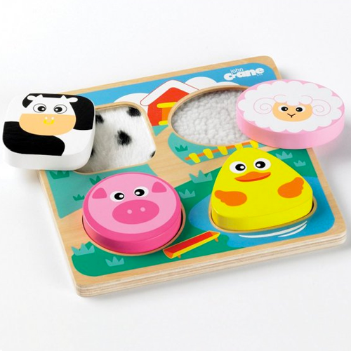

**How does it work?**

1. 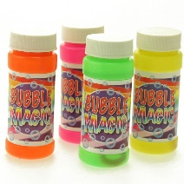Place a picture or a symbol on each side of the board. Place an activity that really motivates the child on the ‘Next’ side of the board. This acts as a ‘reward’, something for the child to aim for.
2. Show the child the board, point to each symbol individually and support the child by saying “Puzzle now….bubbles next”. Use simple key words and always the same phrase.
3. When the child has engaged with the first activity for some time the adult should inform the child by saying “gluing finished… now cars” whilst pointing to the next symbol.
4. Encourage the child to move on by supporting them to “post” the now symbol into a finished box or turning it over before moving onto the next activity.

You can use pictures, symbols or real life objects on the Now and Next board. With time, practice and consistency of use individuals will be able to move onto a longer visual timetable.

Now & next boards can also be used alongside a finished box. When the child has completed the activity from the now and next board they can post the picture into a finished box. Many children enjoy posting and may find posting the pictures gives a clear end to the activity.

**Top Tips –**

* Now and Next boards are portable.
* Make them durable as they will be used a lot!
* They can be personalised – specific activities for specific children.
* Be consistent with your use – same language each time.