 **OBJECTS OF REFERENCE**

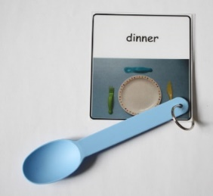**Introduction**

Objects of Reference are objects used to represent a person, activity or event. Over time the person learns that the object stands for that person, activity or event. Objects of Reference are used to help a person understand what is happening in their environment and also be used to help people make choices. Understanding real objects is the first stage of symbolic development. Therefore using objects is considered the most concrete way of representing a word.

**How to make objects of reference**

1. Select the person, activity or event that you want them to understand.

2. Choose an object. It should be easy to understand. Items are often chosen because of their multi -sensory properties. The object of reference must be relevant to the individual, so two people may have different objects of reference for the same toy or activity. Manipulating the object helps the child build up a mental picture of it.  It could be something like:

* + - * The item you use during the activity (e.g. a fork = dinner, a paintbrush = painting)
      * A part of the actual object (e.g. rope = swing, a piece of pottery = gardening)
      * Something like the actual object (e.g. fabric of the same material as the object)
      * Something that is not directly related but can symbolise the activity (e.g. a twig could symbolise going outside for a walk).

3. It is best to start with around 3 Objects of Reference for activities/events that occur very

frequently. You can add more Objects of Reference later.

**How to use Objects of Reference**

1. Just before the individual starts the activity give them the Object of Reference. Use a sign and/or speech e.g. “now we are going to the park”.
2. After giving the Object of Reference it is important to immediately begin the activity to help them understand the connection between the object and activity.
3. It is very important that objects are used consistently every time you do that activity.
4. When an activity starts, take the Object of Reference from the person and put it away. It is a good idea to have a consistent place (e.g. a bag/box) to keep all the objects and put them away when the activity has started.
5. Once the individual has understood the connection between the objects and activities you can use these objects to offer choices relating to these activities.

The following example shows the development of symbolism. It is important that you always start with real objects when you are unsure of a child’s level of understanding.

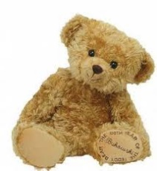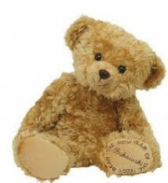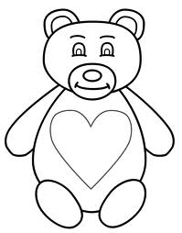

Photograph

Black and white drawing

Real Object

Colour Picture

**Real Object Photo of object Symbol of Object**