

 **SENSORY EXPERIENCES**

[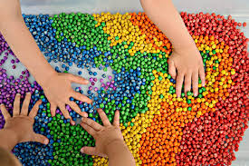](https://www.google.co.uk/imgres?imgurl=https%3A%2F%2Fwww.tslearningcenter.com%2Fassets%2Fuploads%2Fblog_photo%2Fb1535567323sensoryPlay.JPG&imgrefurl=https%3A%2F%2Fwww.tslearningcenter.com%2Fblog%2Fsensory-exploration-is-the-name-of-the-game-&tbnid=nA3WVziMvBfPwM&vet=12ahUKEwiRisWhrePpAhUC-4UKHY0pCEcQMygEegUIARCgAg..i&docid=Ter00yauza1TOM&w=900&h=600&q=sensory%20play%20image&hl=en-GB&safe=vss&ved=2ahUKEwiRisWhrePpAhUC-4UKHY0pCEcQMygEegUIARCgAg)Children explore the world through touch. They need lots of play opportunities and experiences to be able to develop their sensory systems. That is why it’s important for children to have as many different types of play as possible.

Sensory/ Messy play is any activity that stimulates your child’s senses: touch, smell, taste, movement, balance, sight and hearing. It’s a valuable way of engaging children in activities that will heighten their senses and enrich their learning. It’s creative, allowing children to explore their imagination and express feelings. It helps to develop attention and concentration, movement and co-ordination control, their knowledge and understanding of the world, independence, language and social skills. It also encourages choice making and decisions.

However not all children like all textures and this is perfectly normal, it is important to give children plenty of opportunities to experience different touch sensations.

*Never force a child to touch something that they find distressing.*

Do only what the child will tolerate. Tolerance builds up gradually. It is essential to approach activities sensitively, starting with less challenging textures (i.e. a texture that is firm and dry) and building towards more challenging textures (i.e. wet and sloppy). Allow your child to control the level of contact and stop when they need to.

**Activity ideas –**

*Feely Bag/Box* - Place different objects in a bag such as plastic animals, building bricks, textured balls, cotton wool balls, sponge etc. Encourage your child to choose an object from the bag and explore it.

*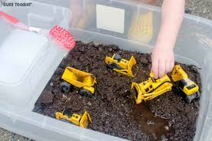Sand/ Soil Play* – Fill a large tray with a layer of sand or soil and draw with your finger making swirly shapes in the sand. Alternatively fill the tray with sand/soil and bury your child’s favourite toy using sticks, spades, spoons to dig and find.

*[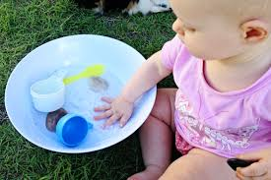](https://www.google.co.uk/imgres?imgurl=https%3A%2F%2Fchildhood101.com%2Fwp-content%2Fuploads%2F2013%2F04%2Fbaby-games-starting-out-with-water-play.jpg&imgrefurl=https%3A%2F%2Fchildhood101.com%2Fbaby-play-ideas-water-play%2F&tbnid=RwA2tVSdD14rdM&vet=12ahUKEwjCupjKrOPpAhVIHBoKHTxvAWUQMyg3egUIARClAQ..i&docid=Wg17ZwOPe-FYBM&w=590&h=394&q=water%20play%20ideas&hl=en-GB&safe=vss&ved=2ahUKEwjCupjKrOPpAhVIHBoKHTxvAWUQMyg3egUIARClAQ)Garden Play* - Play in the garden making mud pies, planting bulbs or collecting leaves and twigs, take a small basket or bag around the garden or park and see what you can find.

*Water Play* - Fill a large plastic tub with water and unbreakable bottles, cups, beakers, sponges and toys and set it outside on the grass. Pouring and measuring are excellent for developing the tactile system.

*Arts and Crafts* - Get children involved in arts and crafts activities using paint, glitter, glue, paper, card, tinfoil, felt, ribbon, foam etc.

**Top tips for sensory/messy play experiences -**

* Allow plenty of time, children need space and time to explore.
* Prepare well, protect surfaces and your clothing with old sheets and old clothes or aprons, while still trying to ensure the child has freedom of movement.
* Comment on the child’s play using lots of rich describing words – squashy, wet, hard, cold, etc.
* HAVE FUN! If the child sees you enjoying yourself then it’s likely they will too.