Ysgol Y Deri Expansion – Sustainability Overview

As part of The Sustainable Communities for Learning Programme ISG are currently working with the Vale of Glamorgan Council to deliver Ysgol Y Deri Expansion for an additional 150 pupil facility to be located on the Cosmeston site to meet future demand for special education.

To address the councils commitment to reduce carbon and respond to the climate emergency, the school has been designed to meet BREEAM Excellent standards, Net Zero Carbon in Operation, low embodied carbon, Net Positive increase in biodiversity and reducing the carbon intensity of the site operations.

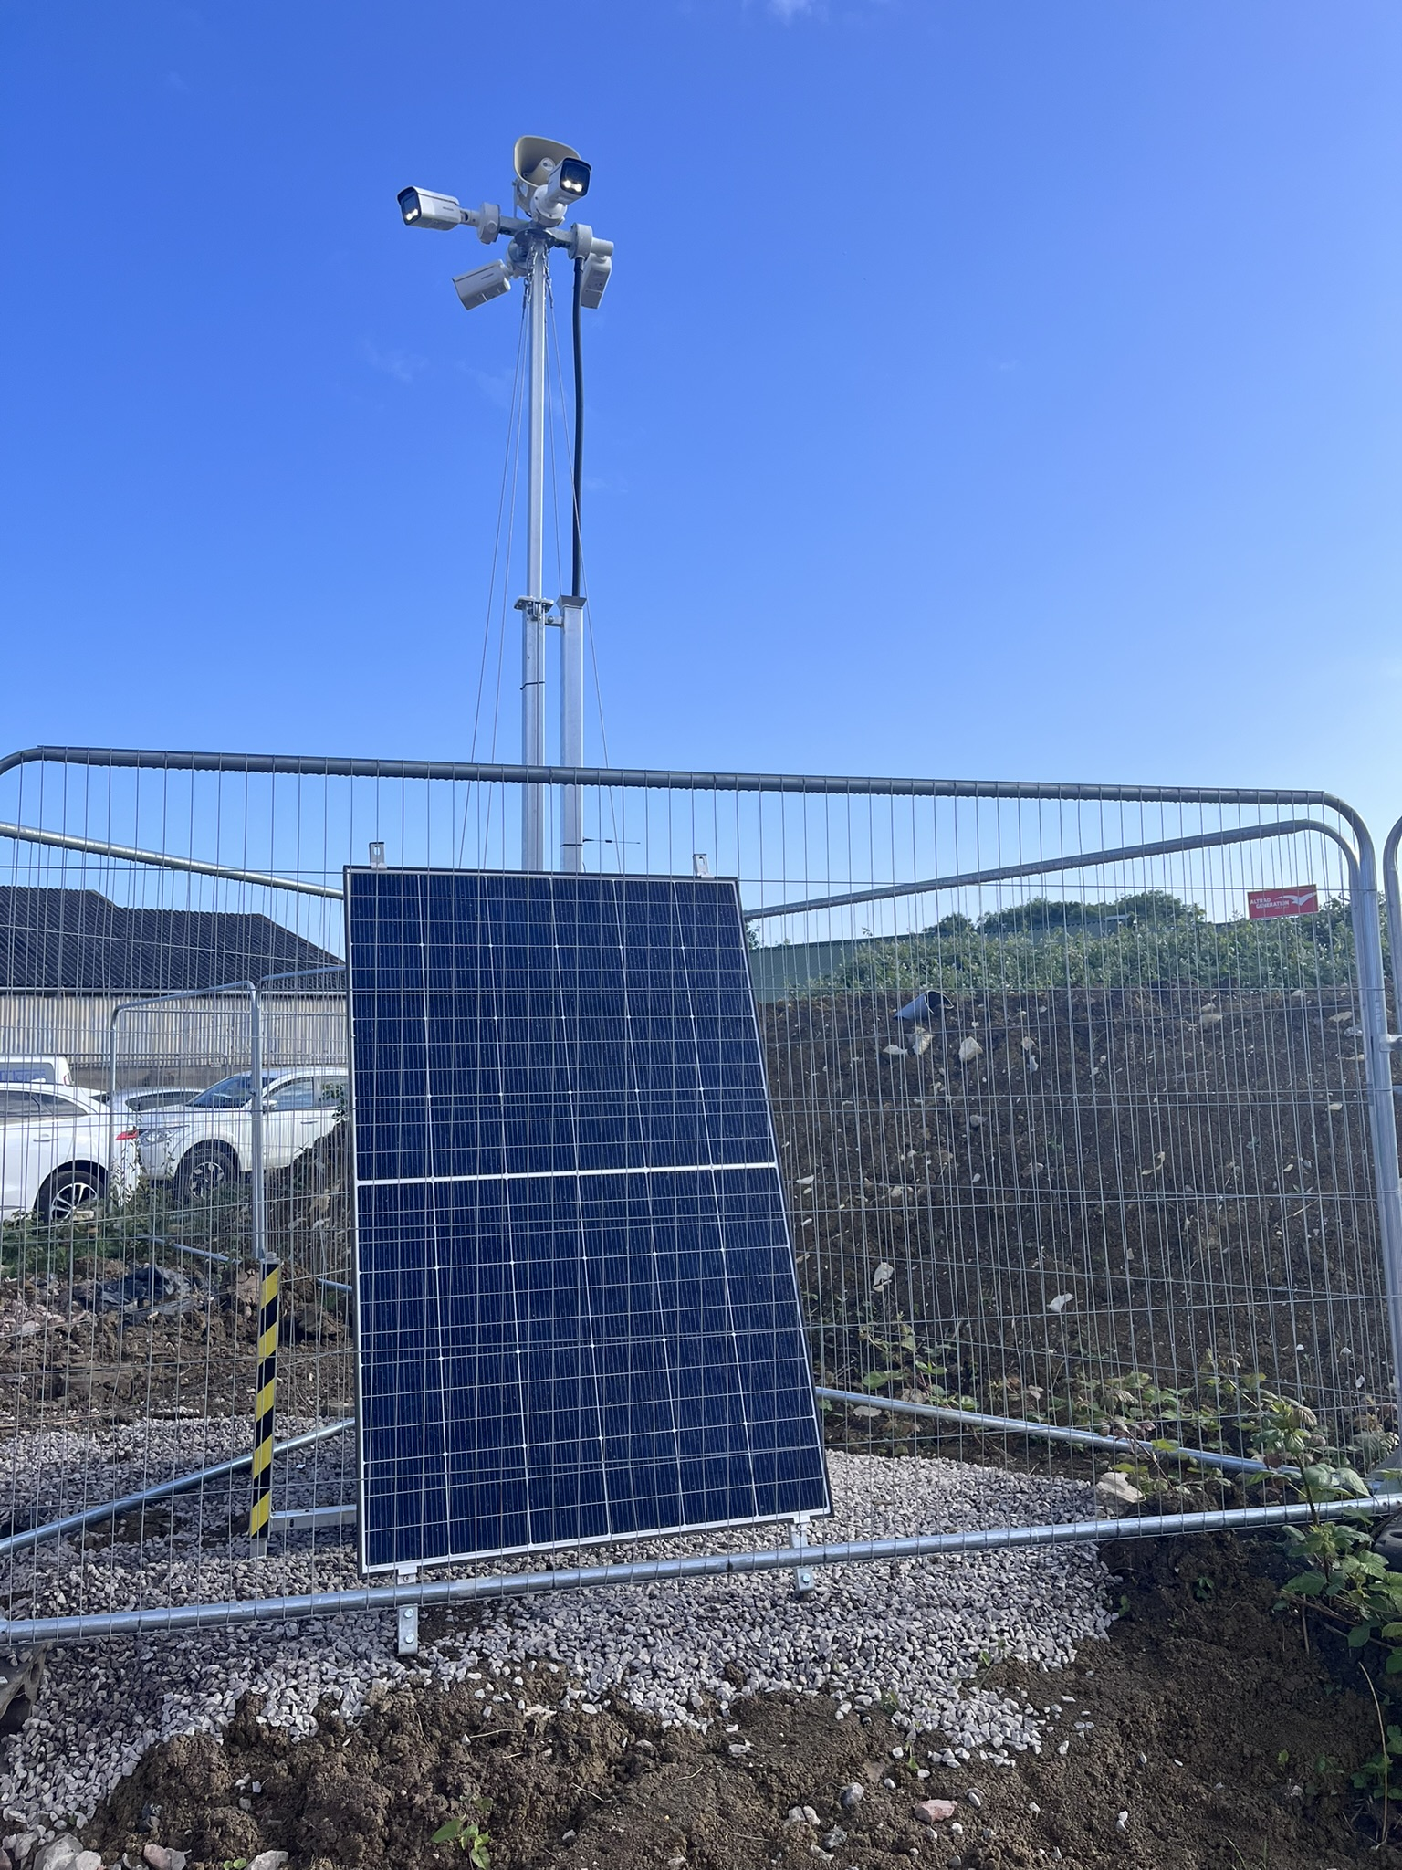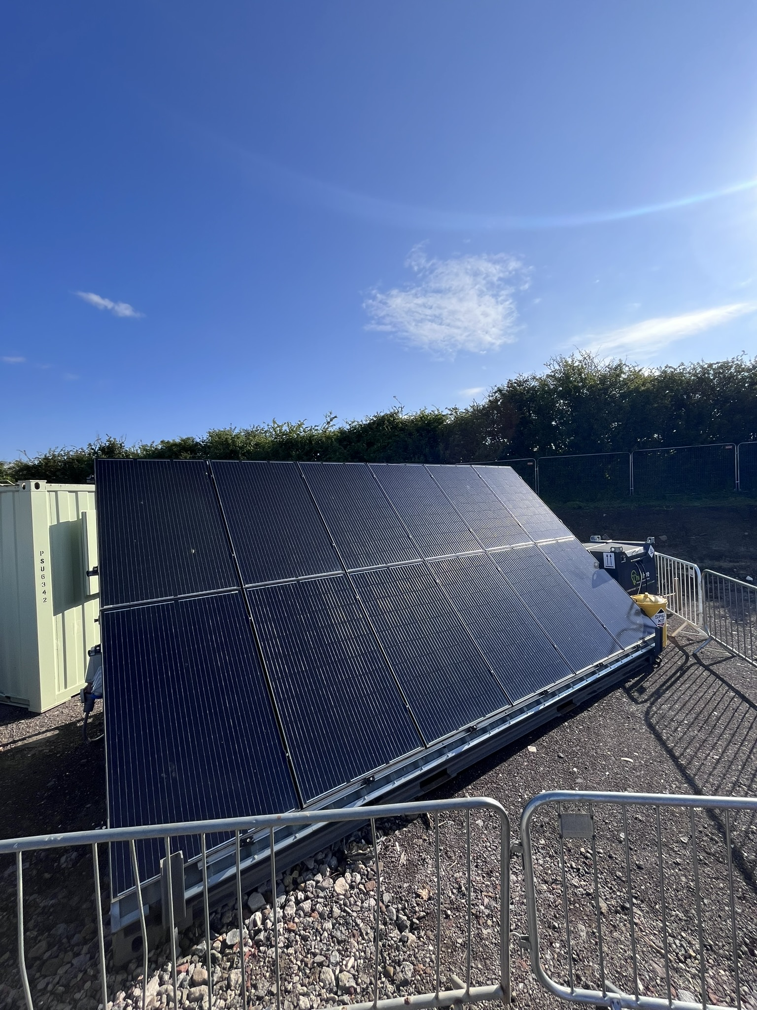

Net Zero Carbon in Operation

The design team followed the UKGBC requirements and LETI benchmarks as part of its net zero strategy to ensure the optimum values for building fabric efficiency, thermal bridging, power efficiency and also considered the balance of daylight and overheating, external shading, openable windows and overall energy consumption.

To help evaluate Ysgol Y Deri Expansion, a complex 3D thermal model was created which considered the building fabric performance – the walls, windows, doors, roof and floor. It then modelled plant loads and efficiencies for heating, ventilation, and lighting. After this, the use of low or zero carbon technologies such as use of renewable energy was considered and then following completion of the building, the modelling looks at how the building will be used– it looks at the way the occupiers will control the systems within the building to gain optimum efficiency. The design also takes into account future climate scenarios.

ISG will work with the school to teach the pupils and staff about sustainability in design and for the learners to be involved in the design and delivery of the school

Embodied Carbon

Reducing the projects embodied carbon is a key driver with an embodied carbon figure of <600kgCo2e/m2 targeted, 20% below the Welsh Government requirement. High % of recycled content has been specified within key construction materials such as the concrete and rebar with timber used within the cladding. Every aspect of the project embraces ways to limit the embodied carbon. Local labour and material is being used where possible to limit transport emissions, with industry leading targets for energy consumption and waste. Excess materials including timber will be re-used or donated to local charities.

All materials used within the build will be to the highest levels of responsible sourcing including BES6001 and/or Environmental Product Declarations and FSC/PEFC. Recycled or re-used materials will be prioritised with an overall minimum target of 15% across the whole build.

Sustainable initiatives onsite

The project team pioneered using a Solartainer and battery storage with a hybrid generator onsite as part of the temporary site set-up. This was procured from ThinkHire which offers a cloud-based dashboard for tracking usage and savings. By using the solar power set up, we have managed to save 563kWh to date. Solar powered security cameras have also been implemented around site with the temporary site cabins also powered by solar PV.

The image below shows the weekly solar and battery usage to power the site office and welfare:

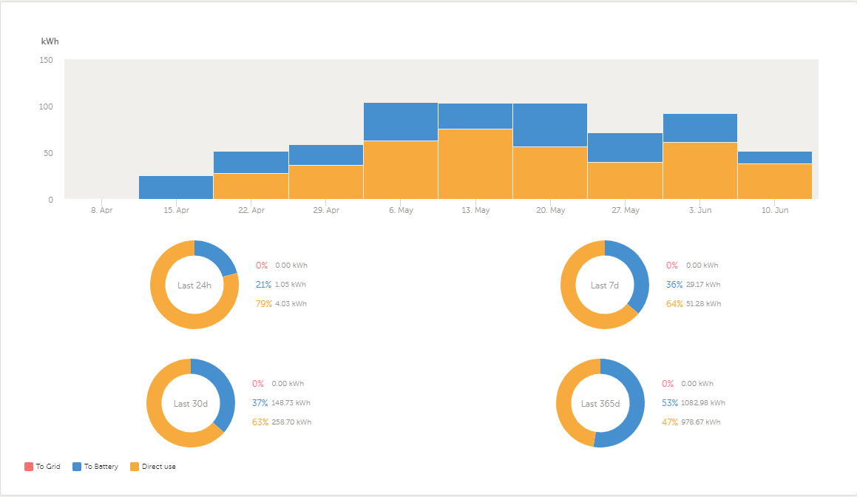

All ISG-procured fuel used for generators and plant is hydrotreated vegetable oil (HVO) as standard across our sites. HVO can offer up to a **90% carbon emission reduction** compared to diesel and forms a critical part of environmental policy and strategic targets. Alongside this, we actively encourage our subcontractors to use HVO and electric or hybrid plant throughout the project.

Ecology and Biodiversity:

As part of the planned design, Fort Road which borders the site boundary was proposed to be widened to accommodate vehicle access. Subsequently, there would be some loss of the southern boundary, inclusive of the boundary hedgerow. Ecological survey work identified this hedgerow as species rich and used by a variety of protected or otherwise notable fauna including nesting birds, foraging/commuting bats and other small mammals.

Maintaining habitat connectivity and resource for these species therefore needed to be considered as part of the development proposals. The layout plan was amended to avoid any net loss of habitat by translocating the southern boundary hedgerow (ca. 779m2 in size) elsewhere in the site boundaries.

Initially, the stretch of hedgerow to be translocated was coppiced using hand tools only and under direct ecological supervision, with hand/fingertip searches to identify any nests undertaken as part of this operation. The translocation of the hedgerow then began in December, with these works again carried out under direct supervision of the ecologist. In addition to the hedgerow translocation, approximately 800m2 of new scrub planting was also provided at the site, providing a net gain in suitable dormouse habitat in the long term.

A post-translocation inspection by the ecologist confirmed that the translocation was successful, and the hedgerow has since become established.

Local biodiversity has been carefully included in the design and will be enhanced through the installation of a green roof, installation of bird and bat boxes and bug hotels, with significant planting of additional trees, wildflowers and SuDS features ensuring the building will provide the pupils and the wider community with access to high quality green spaces.