Applications are to be returned to:  Licensing Team  Public Protection  Civic Offices  Holton Road  Barry  Vale of Glamorgan  CF63 4RU  Tel: 01446 709105 |  | 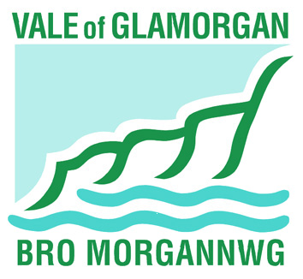
Application for a House to House Collection
House to House Collections Act 1939
1 Applicant details. (all correspondence will be sent to this address)
Mr Mrs Miss Other
Full name
House no and Street
District
Postcode
Telephone number
2. Details of charity to benefit from this collection.
Name
Name/no. and street
District
Postcode
Charity Number
3. Do you represent a company? If so, please provide details.
Name
Company number
4. Detail of charitable purposes that proceeds of the collection are to be applied.
5. Please state the areas in which you intend to collect.
6. Please state the dates between which the collection will be taking place.
to
7. What is the nature of the items to be collected?
Cash Clothing Bric-a-brac Other
8. Please state the total number of collectors to be used.
9. Will any payments be made to the collectors or to other persons? If so, please give details.
10. Will you be applying for licences to collect for the same purpose in other area? If so, to what Authorities?
11. Has the applicant, or anyone associated with the promotion of the collection been refused a licence under the Act, or had a licence revoked? If so, please give details.
12. Is it proposed to promote the collection in conjunction with a street collection?
13. Are you a Home Office exempted charity?
Signed……………………………………………………… Date

Print name

