Applications are to be returned to:  Licensing Team  Public Protection  Civic Offices  Holton Road  Barry  Vale of Glamorgan  CF63 4RU  Tel: 01446 709105 |  |  |  | 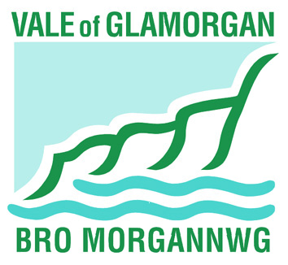
Application for Grant or Renewal of a Boat Licence
Public Health Acts Amendment Act 1907 (c.53)
1. Applicant details.
Mr Mrs Miss Other
Full name
House no and Street
District
Postcode
Telephone number
2. Boat details.
Name of boat
Type of boat
Length
Beam
Keel
Draft
Date of construction
Displacement
Colour
Engine type |  | Petrol Diesel
Has a licence previously been issued for this boat?
Yes No
If yes please give previous issuing authority, licence number and expiry date.

3. Passengers and crew
Number of passengers
Number of crew
4. Category of boat (please tick as appropriate. If other please provide details)
Ferry boat Hire boat Inland pleasure boat Other

5. Address where boat will be let out for hire / or used for carrying passengers
Name/number street
District
Postcode
Other

Declaration

I, the UNDERSIGNED, being the owner of the above-mentioned pleasure boat(s), hereby make application for the same to be licensed.

I HEREBY DECLARE that to the best of my knowledge and belief each of the said boats, together with the equipment thereof, is sound and stable in all respects, and is a fit and proper boat for use on the sea as a motor pleasure boat.

AND I HEREBY UNDERTAKE that I will keep each such boat and its equipment in a proper state of efficiency during the whole time that it plies or is in use for hire.

AND FURTHER that if the Council shall by notice in writing addressed to me, signify its intention to revoke the licence of any boat, such licence shall from and after the date specified in the notice cease to be of any effect.

Signed: ……………………………………………………..

Print name:

Date:

