Applications are to be returned to:  Licensing Team  Public Protection  Civic Offices  Holton Road  Barry  Vale of Glamorgan  CF63 4RU  Tel: 01446 709105 |  |  |  |  | 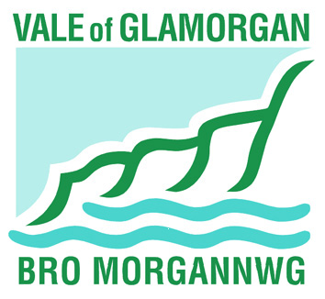
Schedule of Street Collection
Police, Factories Etc. (Miscellaneous Provisions) Act 1916
PERMIT NO.
1. Licence holder details
Mr Mrs Miss Other
Full name
House no and Street
District
Postcode
Telephone number
2. Area to which account relates.
Area
3. Charity or fund that is to benefit from the proceeds.
Name
Charity number
4. Date(s) of collection.
to
Please show NIL entries where applicable
Proceeds of Collection |  |  | Amount | Expenses |  | Amount
From collection boxes |  |  | £ | Printing and stationery |  | £
Interest on proceeds |  |  | £ | Postage |  | £
Other items (please state) |  |  | £ | Advertising |  | £
 |  |  | £ | Collection boxes |  | £
 |  |  | £ | Badges |  | £
 |  |  | £ | Emblems |  | £
 |  |  | £ | Other items (please state) |  | £
Total (A) |  |  | £ | Total (B) |  | £
Balance (A) – (B) = £

Certificate of the licence holder
I certify that to the best of my knowledge and belief that the above is a true account of the proceeds, expenses and application of the proceeds of the collection.

Signed…………………….…………………. Date

Certificate of account
I certify that I have obtained all the information and explanations that I required and that the above is in my opinion a true account of the proceeds, expenses and application of the proceeds of the collection.

Signed…………………………….…………. Date

