Date/Dyddiad | 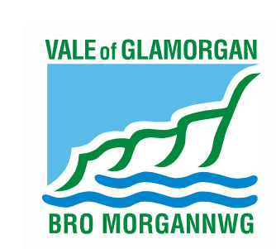  2nd June 2014  The Vale of Glamorgan Council  Directorate of Learning and Skills  Provincial House, Kendrick Road, Barry CF62 8BF  Telephone: (01446) 700111 Textphone: (01446) 741219  Cyngor Bro Morgannwg  Dysgu a Sgiliau,  Tŷ’r Dalaith, Heol Kendrick, Y Barri CF2 8BF  Rhif ffôn: (01446) 700111 Ffôn testun: (01446) 741219  www.valeofglamorgan.gov.uk  www.bromorgannwg.gov.uk
Ask for/Gofynwch am | M Matthews
Telephone/Rhif ffôn | 01446 709727
Fax/Ffacs | 01446 709376
Your Ref/Eich Cyf
My Ref/Cyf | MM/DMAM
e-mail/e-bost | MMatthews@valeofglamorgan.gov.uk

Dear Consultee,

CONSULTATION ON A PROPOSAL TO CREATE A 420 PLACE PRIMARY SCHOOL THROUGH THE AMALGAMATION OF DINAS POWYS INFANT AND MURCH JUNIOR SCHOOLS BY CLOSING MURCH JUNIOR SCHOOL AND EXTENDING THE AGE RANGE OF DINAS POWYS INFANTS SCHOOL

The Local Authority is proposing to amalgamate Dinas Powys Infants and Murch Junior Schools. The council has a statutory duty to consult on the proposal with prescribed consultees as part of the consultation process.

The consultation period runs from the 2nd June 2014 to the 28th July 2014.

I enclose a copy of the consultation document that details the proposal in full and how you can respond to the consultation, the local authority would welcome your views on the proposal.

If you have any queries on the consultation, please contact Mike Matthews on 01446 709727 or alternatively e-mail at MMatthews@valeofglamorgan.gov.uk.

Yours sincerely

M Matthews

Mike Matthews
Directorate of Learning and Skills

