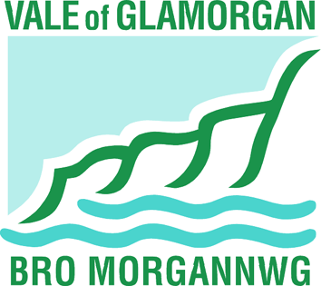

COMMUNITY IMPACT ASSESSMENT

On the proposal to amalgamate Cadoxton Nursery and Cadoxton Primary schools by:

1. Extending the age range of Cadoxton Primary School from 4 – 11 to 3 - 11 years; and

2. discontinuing Cadoxton Nursery School

Directorate of Learning and Skills
The Vale of Glamorgan Council

Contents
Introduction 3
National Context 3
Local Policy Context 3
Community Impact 4
Catchment area 4
Existing School Facilities/Activities 6
Traffic issues/Walking routes 8
Conclusion 8

Introduction

The Council is proposing to amalgamate Cadoxton Nursery School and Cadoxton Primary School from 01 September 2016 and make an all through 3 to 11 years primary school located on the existing sites of Cadoxton Nursery and Primary schools.

Cadoxton Nursery and Cadoxton Primary schools are both located in Cadoxton which is in the eastern side of Barry. They are approximately 20 metres apart from each other on the same road within the Cadoc electoral ward. The schools are located in a ‘Communities First’ and ‘Flying Start’ area, identified under the Welsh Government’s schemes for children in the most disadvantaged communities in Wales.

The amalgamated school would have a nursery class with capacity for 100 part time places as is currently provided. Cadoxton Primary School would also continue to provide 60 places (2 classes) for each year group, from reception year through to year 6, with a total capacity of 420 pupil places. The amalgamated school would continue to make use of both existing sites and be no larger or smaller than the two separate existing schools. Nursery provision would continue to be provided from the current nursery building.

Over the past 10 years the Council has sought to move towards a primary school model for 3 to 11 years education by amalgamating separate infant and junior schools where there has been an opportunity to do so.

There are currently 3 stand-alone nursery schools in the Vale of Glamorgan: Cadoxton Nursery School (Barry), Bute Cottage Nursery School (Penarth) and Cogan Nursery School (Penarth). Of the 15 primary schools in Barry, 14 have nursery classes which are part of the school. An amalgamation would move the two schools at Cadoxton in line with the rest of the primary schools in Barry. The children attending the nursery class would become part of the whole school family from their first day at school. Many families then choose to apply to the school for entry into the reception classes.

National Context

The key statutory guidance for local authorities in developing statutory proposals for changes for school organisation is in accordance with section 42 of the School Standards and Organisation Act 2013 and the School Organisation Code 2013. When considering proposals the authority must consider the impact on the local community, particularly in rural areas and in areas designated for communities’ first programmes or successor programmes.

Local Policy Context

The Vale of Glamorgan is committed to its community strategy and vision that the Vale is a place:

- That is safe, clean and attractive, where individuals and communities have sustainable opportunities to improve their health, learning and skills, prosperity and well being, and;
- Where there is a strong sense of community in which local groups and individuals have the capacity and incentive to make an effective contribution to the future sustainability of the area.

A key outcome for children is that they have the skills, knowledge and abilities required to maximise their opportunities and provide them and their families with a flying start.

Community Impact

Catchment area

Cadoxton Primary and Nursery schools are classified as community schools and serve their local community through their ‘catchment area’. The Council is the admission authority for the schools. Both Cadoxton Primary and Nursery schools accommodate pupils from within their catchment areas, and the Council will continue to plan to provide sufficient places to meet all on-going demand. Parents have a right to state a preference for any school.
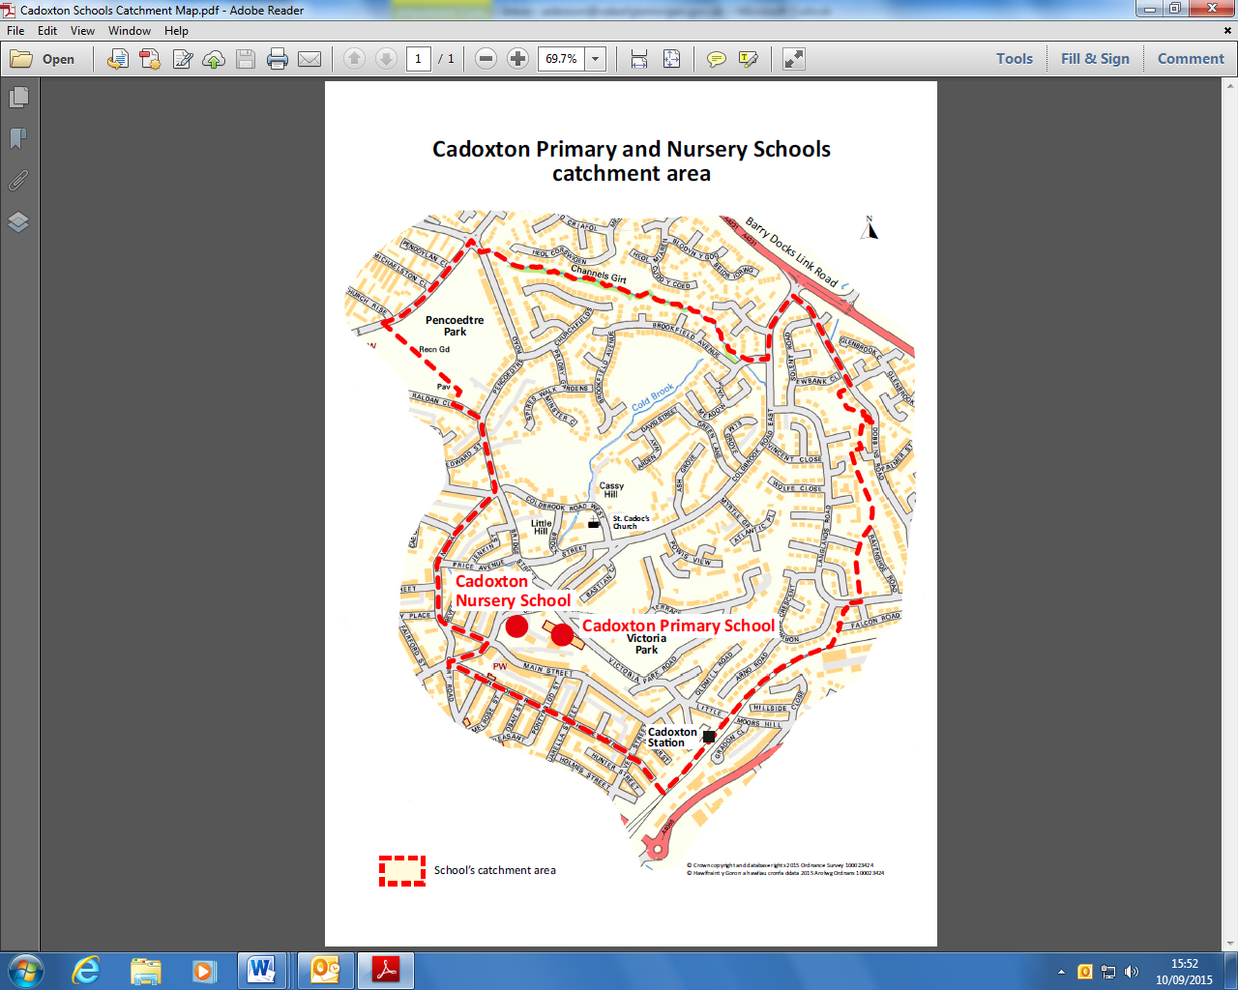
The following tables illustrate the effect of parental preference and pupil movement at Cadoxton Primary School:

Primary catchment area schools of children attending the school during the
academic year 2014/15

Catchment Area school | School Capacity | School Number on Roll | Cadoxton | Jenner Park | Palmerston | Other Barry Schools | Penarth and Dinas Schools | Outside Vale
Cadoxton Primary School | 420 | 366 | 96 | 140 | 51 | 74 | 2 | 3

The following table illustrates the effect of parental preference and pupil movement at Cadoxton Nursery School:

Nursery catchment area schools of children attending the school during the
academic year 2014/15

Catchment Area school | School Capacity | School Number on Roll | Cadoxton | Colcot | Holton | Jenner | Oakfield | Palmerston
Cadoxton Nursery School | 100 | 100 | 40 | 2 | 2 | 30 | 15 | 11

Cadoxton Primary and Nursery School catchment area analysis

Cadoxton Nursery and Primary schools have a catchment area serving Cadoxton and surrounding area of eastern Barry.

In January 2015 there were 314 children of primary age (4 - 11) living within the school’s catchment area compared to a school capacity for 420 children. Of the 314 catchment area children 96 (31%) attended Cadoxton Primary school.

At nursery level there were 106 children of nursery school age entitled to a nursery place for the academic year 2014/15, living in the school catchment area, of which 40 (38%) attended Cadoxton Nursery.

At January 2015 there were 265 (72%) children attending the primary school that live within other Barry school catchment boundaries. At nursery level 60 (60%) children attending the nursery school during the academic year 2014/15, live in other Barry school catchment boundaries.

Existing School Facilities/Activities

Shared School Activities

Cadoxton Nursery School and Cadoxton Primary School both provide essential support for families within the community, through implementation of the ‘Putting Families First’ schools and community programme. The schools also act as a ‘Drop-In’ for those parents/carers who require 1:1 support for personal issues. The programme provides parents, guardians and carers with children aged 0-11 years an informal network of support, helping to develop confidence, new skills and provides greater access to information.

The programme brings together a range of local services and offers a menu of interventions which support families. These include:

- Helping Children Learn in the Foundation Phase
- Reading Readiness
- Ready for Maths
- Steps to Excellence
- Supporting Family Life
- Building Confident Families
- Family Links Nurture Programme
- Play Development
- Health and Wellbeing
- Foodwise
- Adult Education
- Drugs and Alcohol Awareness
- First Aid
- Family Information Service
- Volunteering Service
- Citizens Advice Bureau

Open door policies are in operation to provide guidance and support for families. Parents are able to meet and talk with all staff as circumstances dictate. As a result both schools are regarded as an extension of the family and a Community Hub for any members of the extended family.

The schools are situated within a Flying Start area and where core group and case conference meetings are conducted within the school setting. The schools work with many agencies including social services, health visitors and the police.

Cadoxton Nursery
Cadoxton Nursery is a stand-alone nursery located approximately 20 metres away from Cadoxton Primary School that share the same postal address.

The school runs a number of activities for parents to attend. This includes a Language and Play course (LAP) which runs twice a year to encourage language and maths skills. Language and mathematical workshops for parents and carers are held termly, offering ways in which they can support their child’s learning. Every Wednesday, during a nursery session, parents are invited into the Cwtch room, where they are able to meet to discuss their needs as parents and families, talk with staff, meet with other parents and to take part in fun, informative activities.
Parent and child healthy cooking sessions are available during the autumn term. The school also runs art sessions in the summer term to enable parents to do outside work with their children.
During the spring and summer term the school runs a computer club for parents to spend time with their children before school utilising the computers, whiteboard, Beebot (programmable floor robot) and cameras using the software used in the school. Laptops and digital cameras are available as part of the school’s library loan scheme. The school offers computer access to parents/carers to aid with form filling and fact finding.
Cadoxton Primary School

Cadoxton Primary School operates a free Welsh Government run breakfast club for pupils from 8 - 9 am. There is no charge for this service and children can attend from any age group across the school.

The school hosts a childcare provider in Cadogs Café, located on the school site, from 3.15 – 5.15 pm from Monday to Thursday, enabling parents to access wrap around care for their children in a safe and stimulating environment.

Nurture group and skills development schemes are available for parents and family members in association with Families First to engage in a number of activities and programmes. The schemes offer programmes such as Maths and Reading Readiness for reception age children. Families are encouraged to take part in Families and Schools Together Programme (FAST) that builds positive relationships between schools, families and local communities to ensure children thrive at school.

A range of extra-curricular and after school club activities for children are provided by the school as follows:

- Choir
- Netball/Football
- Gardening Club
- Cookery Club
- Computer club
- Dance Club
- Film Club
- Clubinov8

The school offers its facilities to a number of groups and clubs to meet at the school on a regular basis to include;

- Reception Story Café
- Lego group run by parents
- Geocaching Club
- Credit Union
- Fruit & Veg Co-op

A number of Vale of Glamorgan play schemes are available at the school to parents for children to attend during school term breaks.

Cadogs Café runs a number of groups for the community and parents including Cadoxton Family and Friends, Cadoxton Food Co-op, anti-bullying, other sessions for keep fit, walking and bike maintenance/repair. Cadoxton Family and Friends is an opportunity to meet new friends, learn new skills and to meet with agencies that work with the school.

The school has a sports hall that is run by the school and provides a range of facilities for the public, schools and local community operating until 10 pm.

All existing activities and facilities for the community, parents, children and extended family will continue with the proposed amalgamation of the nursery and primary schools.

Traffic issues/Walking routes

Under these proposals there are no plans to change the Council’s policy on the transport of children to and from schools.

The Council has a statutory duty to provide free school transport for pupils of statutory school age who reside beyond walking distance to the nearest appropriate school.

The Council’s school transport policy can be viewed on the Council’s website: http://www.valeofglamorgan.gov.uk/en/working/education_and_skills/schools/school_transport/school_transport.aspx

Conclusion

The nursery has strong links to the school and has worked with it to develop and prepare pre-school children to be ready to become part of the community of the school. The existing nursery will remain where it is and become part of the school.

Cadoxton Primary and Nursery schools currently offer a range of activities for pupils and parents and make their facilities available to outside groups. The primary school operates a breakfast club and after school club together with after school childcare in Cadogs Café providing wrap around care for parents. Both schools have strong links to the Cadoc ward and to the local community and support many local groups. It is proposed that all existing activities and facilities for pupils, parents and the community will continue with the proposed amalgamation of the schools.

The Community Impact Assessment demonstrates that the proposal to extend the age range of Cadoxton Primary school from 4 – 11 to 3 - 11 years by establishing a nursery unit within the school will result in:

- Continuity of provision and cohesion for parents;
- Continuing to develop the sense of belonging that is already evident at both schools, and;
- Help for families new to the area adjust to their new community by helping them link into established networks facilitated through a single school.
The key subject areas of the assessment conclude that:
- The community impact assessment has been done in line with national and local policy;
- There will be no effect on school catchment areas;
- There will be no reduction in activities and facilities offered at present in both schools, and;
- New and existing activities and facilities would be open to a wider audience through a single, amalgamated school.

For more details and to see the full proposal, visit:
www.valeofglamorgan.gov.uk/cadoxtonschools

