Date/Dyddiad | 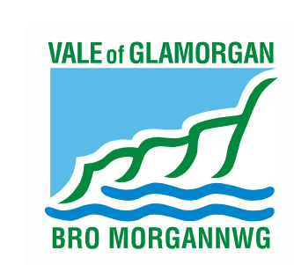  04 January 2016  The Vale of Glamorgan Council  Directorate of Learning and Skills  Provincial House, Kendrick Road, Barry CF62 8BF  Telephone: (01446) 700111 Textphone: (01446) 741219  Cyngor Bro Morgannwg  Dysgu a Sgiliau,  Tŷ’r Dalaith, Heol Kendrick, Y Barri CF2 8BF  Rhif ffôn: (01446) 700111 Ffôn testun: (01446) 741219  www.valeofglamorgan.gov.uk  www.bromorgannwg.gov.uk
Ask for/Gofynwch am | M Matthews
Telephone/Rhif ffôn | 01446 709727
Fax/Ffacs | 01446 709376
Your Ref/Eich Cyf
My Ref/Cyf | MM/CadoxtonSchools
e-mail/e-bost | MMatthews@valeofglamorgan.gov.uk

To: Parents and Guardians of children attending Cadoxton Primary School, Barry;
Parents and Guardians of children attending Cadoxton Nursery School, Barry;
Headteacher, Staff and Governors of Cadoxton Primary and Cadoxton Nursery Schools; and

Prescribed Consultees

Dear Consultee,

Consultation on the proposal to amalgamate Cadoxton Nursery and Primary schools

I enclose a copy of the consultation document that describes our proposal and explains how you can respond.

The consultation period runs from 04 January 2016 to 15 February 2016.

Drop in sessions for parents have been arranged at the Victoria Park Community Centre, Church Road, Barry, CF63 1JY on

Thursday 4th February 2016 from 11.30 am to 2 pm or Tuesday 9th February from 11.30 am to 2 pm and at

Cadoxton Methodist Church, Church Road, Cadoxton, Barry CF63 1JX on

Thursday 4th February 2016 from 3 pm to 6 pm or Tuesday 9th February from 3 pm to 6 pm.

Parents can drop in at any point during these sessions. The consultation document also provides information about other meetings that will be held as part of the consultation exercise.

The document is available to view on line at www.valeofglamorgan.gov.uk/cadoxtonschools

If you have any queries, please contact Mike Matthews on 01446 709727 or e-mail at MMatthews@valeofglamorgan.gov.uk

We look forward to hearing your views.

Yours sincerely,

A Brown

Anne Brown
School Organisation Manager

