Date/Dyddiad | 26 June 2023  The Vale of Glamorgan Council  Learning and Skills  Civic Offices, Holton Road, Barry CF63 4RU  Telephone: (01446) 700111 www.valeofglamorgan.gov.uk  Cyngor Bro Morgannwg  Dysgu a Sgiliau  Swyddfeydd Dinesig, Heol Holton, Y Barri CF63 4RU  Rhif ffôn: (01446) 700111 www.bromorgannwg.gov.uk
Ask for/Gofynwch am | N Burton
Telephone/Rhif ffôn | 01446 709828
Fax/Ffacs
e-mail/e-bost | sustainablecommunitiesforlearning@valeofglamorgan.gov.uk
My Ref/Cyf | SCfL/YIM
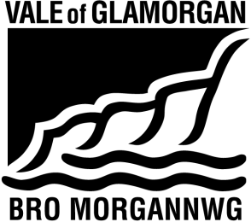

To: Parents, Carers and Guardians of children attending Ysgol Iolo Morganwg;
Headteacher, Staff and Governing Body of Ysgol Iolo Morganwg;
Prescribed Consultees

Dear Consultee,

Proposal to provide additional school places to meet the future demand for Welsh Medium education by expanding Ysgol Iolo Morganwg from 210 places to 420 places from September 2025.

I am writing to advise that the Council’s Cabinet have agreed to publish a statutory notice to expand Ysgol Iolo Morganwg from 210 places to 420 places from September 2025. A copy of the notice is enclosed and is also available to view and download from the Council’s website at https://www.valeofglamorgan.gov.uk/en/living/schools/Consultations/Expanding-Ysgol-Iolo-Morganwg.aspx

Yours faithfully,



Trevor Baker
Head of Strategy, Community Learning & Resources

