Date/Dyddiad | 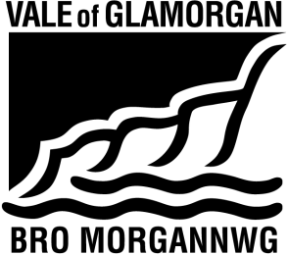  5 June 2023
Ask for/Gofynwch am | N Burton
Telephone/Rhif ffôn | 07759930272
Fax/Ffacs
e-mail/e-bost | sustainablecommunitiesforlearning@valeofglamorgan.gov.uk
Your Ref/Eich Cyf | The Vale of Glamorgan Council  Learning and Skills  Civic Offices, Holton Road, Barry CF63 4RU  Telephone: (01446) 700111 www.valeofglamorgan.gov.uk  Cyngor Bro Morgannwg  Dysgu a Sgiliau  Swyddfeydd Dinesig, Heol Holton, Y Barri CF63 4RU  Rhif ffôn: (01446) 700111 www.bromorgannwg.gov.uk
My Ref/Cyf | SCfL/YIM

To: Parents, Carers and Guardians of children attending Ysgol Iolo Morganwg;
Headteacher, Staff and Governing Body of Ysgol Iolo Morganwg;
Prescribed Consultees

Dear Consultee,

Proposal to provide additional school places to meet the future demand for Welsh Medium education by expanding Ysgol Iolo Morganwg from 210 places to 420 places from September 2025.

We are grateful to everyone who took the time to consider our proposal and would like to thank those who let us know their views. All comments were considered by the Council’s Cabinet on 25 May 2023 who agreed to the publication of the consultation report on the proposal. The consultation report is available to view and download from the Council website at https://www.valeofglamorgan.gov.uk/en/living/schools/Consultations/Expanding-Ysgol-Iolo-Morganwg.aspx;

If you would like a hard copy of the report, please contact a member of the Sustainable Communities for Learning Programme Team on 01446 709828 or email sustainablecommunitiesforlearning@valeofglamorgan.gov.uk. The report is also available to view at Ysgol Iolo Morganwg.

Yours sincerely,



Trevor Baker
Head of Strategy, Community Learning & Resources

