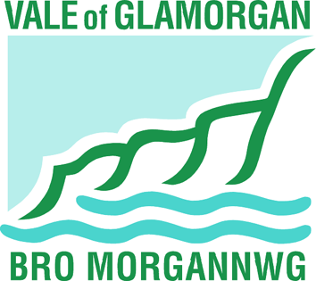

THE VALE OF GLAMORGAN COUNCIL,
CIVIC OFFICES, HOLTON ROAD,
BARRY CF63 4RU

STATUTORY NOTICE TO AMALGAMATE DINAS POWYS INFANTS AND MURCH JUNIOR COMMUNITY SCHOOLS FROM JANUARY 2015

NOTICE IS GIVEN in accordance with section 42 and 43 of the School Standards and Organisation (Wales) Act 2013 and the School Organisation Code that the Vale of Glamorgan Council, having consulted such persons as required, propose to create a 420 place English medium primary school for boys and girls through the amalgamation of Dinas Powys Infant School, Cardiff Road, Dinas Powys, CF64 4JU and Murch Junior School, Fairoaks, Dinas Powys, CF64 4QU by closing Murch Junior School and extending the age range of Dinas Powys Infants School from 3-7 to 3-11 to be maintained by the Vale of Glamorgan Council. Dinas Powys Infant and Murch Junior Schools are currently maintained by the Vale of Glamorgan Council.

The Vale of Glamorgan Council undertook a period of consultation before deciding to publish this proposal. A consultation report containing a summary of the issues raised by consultees, the proposer’s responses and the views of Estyn is available to view on the Vale of Glamorgan website at the following address www.valeofglamorgan.gov.uk/dinasmurchamalgamation

It is proposed to implement the proposal on 5th January 2015.

The proposed new school will be a community school.

The Vale of Glamorgan Council will be the admission authority. The admission number for pupils aged 4/5 at the new school in the first school year in which the proposals have been implemented is 60. Admission arrangements do not make provision for selection by ability (pupil banding).

The new school’s pupil capacity will be 420. The school will operate over the existing school sites of Dinas Powys Infant School and Murch Junior School from January 2015, under a single governing body and headteacher. All pupils currently in attendance at both schools will be given a place in the amalgamated school.

The amalgamated school will provide for 72 nursery and 420 primary school places that is equivalent to the places currently available at Dinas Powys Infant and Murch Junior Schools. The overall number of nursery and primary places available for children in the Dinas Powys area does not alter as a result of this proposal.

The All Wales Learner travel arrangements provide eligibility for school transport if a primary age pupil lives more than two miles to their nearest or designated catchment area school. School transport arrangements, eligibility and accessibility are not affected by this proposal.

Within a period of 28 days after the date of publication of the proposals, that is to say by 28th October 2014, any person may object to the proposals.

Objections should be sent to Jennifer Hill, Director of Learning and Skills, Vale of Glamorgan Council, Provincial House, Kendrick Road, Barry CF62 8BF or e-mail dinasmurchamalg@valeofglamorgan.gov.uk

Signed: 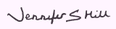

Jennifer Hill, Director of Learning and Skills
30th September 2014

EXPLANATORY NOTE – which does not form part of the statutory notice

The Council proposes to provide a 420 place all through Community Primary School in Dinas Powys through the amalgamation of Dinas Powys Infant and Murch Junior Schools.

The school would provide 60 places per year group, which is the same number of places currently provided at the two existing schools. The capacity of the school would be 420 places. The primary school would, therefore, be no larger or smaller than the two existing schools in terms of the number of places available for children. The amalgamated school would also have a nursery class providing the same number of places as currently provided at the infant school.

The substantive headteacher of Dinas Powys Infants School would remain the headteacher of the amalgamated school and the governing body of the infant school would remain the governing body of the amalgamated school and would be expanded from its current number of 14 to 18.

Details of how the amalgamated school will operate over two sites, its common policies and procedures and its staffing structures would be developed by the governing body and Headteacher of the amalgamated school.

The Council is the admission authority for the school. Normal admission arrangements currently apply where catchment area residence is a high priority for entry in the event of oversubscription.

