Date/Dyddiad | 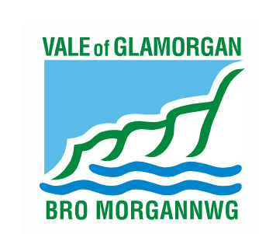  24th September 2014  The Vale of Glamorgan Council  Directorate of Learning and Skills  Provincial House, Kendrick Road, Barry CF62 8BF  Telephone: (01446) 700111 Textphone: (01446) 741219  Cyngor Bro Morgannwg  Dysgu a Sgiliau,  Tŷ’r Dalaith, Heol Kendrick, Y Barri CF2 8BF  Rhif ffôn: (01446) 700111 Ffôn testun: (01446) 741219  www.valeofglamorgan.gov.uk  www.bromorgannwg.gov.uk
Ask for/Gofynwch am | M Matthews
Telephone/Rhif ffôn | 01446 709727
Fax/Ffacs | 01446 709376
Your Ref/Eich Cyf
My Ref/Cyf | MM/YNYB
e-mail/e-bost | MMatthews@valeofglamorgan.gov.uk

To: Parents and Guardians of children attending Ysgol Gymraeg Nant Talwg and Ysgol Gyfun
Bro Morgannwg:
Headteacher, Staff and Governors of Ysgol Gymraeg Nant Talwg and Ysgol Gyfun Bro
Morgannwg:
Prescribed Consultees

Dear Consultee,

CONSULTATION ON A PROPOSAL TO CREATE A NEW 1,361 PLACE 3 – 19 ALL THROUGH SCHOOL THROUGH THE AMALGAMATION OF YSGOL GYMRAEG NANT TALWG AND YSGOL GYFUN BRO MORGANNWG BY CLOSING YSGOL GYMRAEG NANT TALWG AND EXTENDING THE AGE RANGE OF YSGOL GYFUN BRO MORGANNWG

The local authority is consulting on a proposal to amalgamate Ysgol Gymraeg Nant Talwg and Ysgol Gyfun Bro Morgannwg. The Council has a statutory duty to consult on the proposal with prescribed consultees as part of the consultation process.

The consultation period runs from the 24th September 2014 to the 12th November 2014.

I enclose a copy of the consultation document that details the proposal in full and how you can respond to the consultation, the local authority would welcome your views on the proposal.
The document is available to view on line at www.valeofglamorgan.gov.uk/nanttalwgbromorgannwgamalgamation

If you have any queries on the consultation or require a hard copy of the document, please contact Mike Matthews on 01446 709727 or alternatively e-mail at MMatthews@valeofglamorgan.gov.uk

Yours sincerely

M Matthews

Mike Matthews
Directorate of Learning and Skills

