Date/Dyddiad | 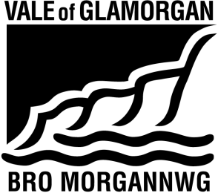  10th May 2014  The Vale of Glamorgan Council  Learning and Skills  Provincial House, Kendrick Road, Barry CF62 8BF  Telephone: (01446) 700111 www.valeofglamorgan.gov.uk  Cyngor Bro Morgannwg  Dysgu a Sgiliau  Tŷ’r Dalaith, Heol Kendrick, Y Barri CF2 8BF  Rhif ffôn: (01446) 700111 www.bromorgannwg.gov.uk
Ask for/Gofynwch am | M Matthews
Telephone/Rhif ffôn | 01446 709727
Fax/Ffacs | 01446 709376
e-mail/e-bost | MMatthews@valeofglamorgan.gov.uk
Your Ref/Eich Cyf | MM/WM
My Ref/Cyf

Dear Stakeholder,

PROPOSAL TO EXPAND YSGOL GWAUN Y NANT PRIMARY SCHOOL

On 28th April 2014, the Vale of Glamorgan Council’s Cabinet agreed to expand Ysgol Gwaun Y Nant from 210 places to 420 places incrementally from September 2015 subject to Welsh Government grant funding being awarded from the 21st Century Schools Programme.

The Council received no statutory objections in response to the amalgamation proposal. Cabinet were satisfied that the proposal will;

- Improve the standard of education provision overall in the area and ensure the delivery of a broad and balanced curriculum;
- Respond to the increased demand for Welsh medium education in the Barry area to ensure statutory requirements are met for the future;
- Meet the increased demand for Welsh medium provision by increasing the capacity of Ysgol Gwaun y Nant from 210 to 420 places starting in September 2015. The proposal will involve the building of a new pattern book design school for Oak Field Primary and remodel the school building currently occupied by both Gwaun y Nant and Oak Field schools to increase capacity to 420 places for Ysgol Gwaun y Nant; and
- Increase the number of places in each age group from 30 to 60 at Ysgol Gwaun y Nant;

The Council will take all practicable steps to minimise any disruption for pupils in the implementation of the proposal, subject to Welsh Government grant funding, by working closely with the headteachers and governing bodies.

Yours sincerely

M Matthews

Mike Matthews
Directorate of Learning and Skills

